Project Title: Assignment Tracker

Overview: A web application to track assignments with CRUD functionality.

User Stories:

* + I want to be able to add a new task.
  + I want to be able to view all tasks.
  + I want to be able to update a task.
  + I want to be able to delete a task.

Wireframes:

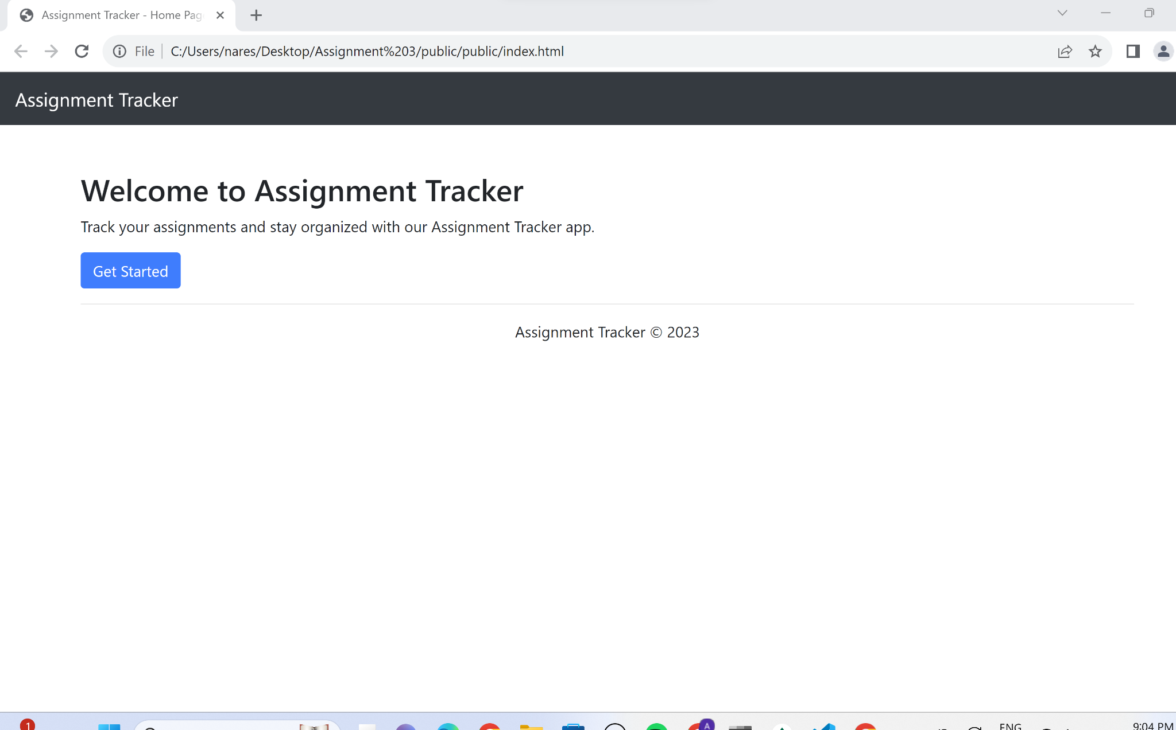

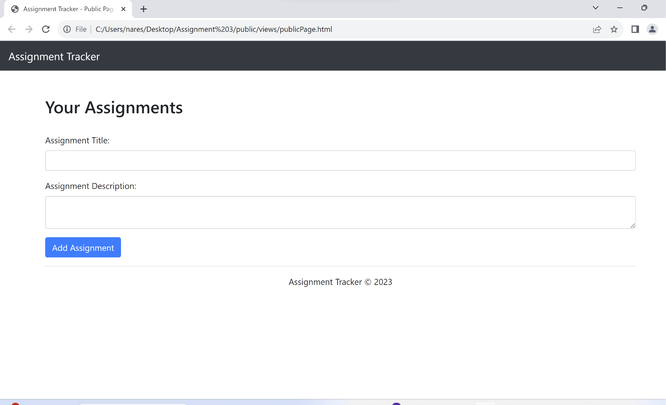

Database Schema:

* + Collection: Assignments
    - Fields: title, description/status